Chronic Kidney Disease Prediction

Problem Statement:
A requirement from the Hospital, Management asked us to create a predictive model which will predict the Chronic Kidney Disease (CKD) based on the several parameters. The Client has provided the dataset of the same.
Requirement:
To predict Chronic Kidney Disease.
Dataset:
Input: 'age', 'bp', 'sg', 'al', 'su', 'rbc', 'pc', 'pcc', 'ba', 'bgr', 'bu','sc', 'sod', 'pot', 'hrmo', 'pcv', 'wc', 'rc', 'htn', 'dm', 'cad','appet', 'pe', 'ane'
Output: 'classification'
Stage 1: Domain Selection
Insurance charges dataset has numerical values. So, the domain selection here is Machine Learning.
Stage 2: Learning Selection
Requirement is clear. Inputs and output are defined. So, the learning selection here is Supervised Learning.
Stage 3: Classification/Regression
The output has categorical value. So, we have to choose Classification under supervised learning.
Stage 4: Model Creation/ Learning Phase
Step 1: Data Collection
Chronic Kidney Disease dataset has been provided by the client.
Input: 'age', 'bp', 'sg', 'al', 'su', 'rbc', 'pc', 'pcc', 'ba', 'bgr', 'bu','sc', 'sod', 'pot', 'hrmo', 'pcv', 'wc', 'rc', 'htn', 'dm', 'cad','appet', 'pe', 'ane'
Output: 'classification'
Total number of columns=25
Total number of rows=399

Step 2: Data Preprocessing
Data preprocessing is required for the categorical columns. Categorical columns have Nominal Data. So, we have to convert these columns using One-Hot Encoding method.
Step 3: Input/Output Split
From the dataset, split inputs and output.
Input: 'age', 'bp', 'sg', 'al', 'su', 'rbc', 'pc', 'pcc', 'ba', 'bgr', 'bu','sc', 'sod', 'pot', 'hrmo', 'pcv', 'wc', 'rc', 'htn', 'dm', 'cad','appet', 'pe', 'ane'
Output: 'classification'
Step 4: Split Train and Test Set
From the dataset, take most of the data for the training set (70%) and a smaller portion for the test set (30%).
Step 5: Model Creation
To develop the model, several classification algorithms were evaluated. The algorithm with the highest accuracy, recall, precision, f1_score, macro average, weighted average and roc_auc score is selected as the best model. The classification algorithms and their corresponding classification reports are listed below.
Confusion Matrix:
Predicted | Actual | No Chronic Kidney Disease | Chronic Kidney Disease
No Chronic Kidney Disease |  | 45 | 0
Chronic Kidney Disease |  | 1 | 74

Logistic Regression:
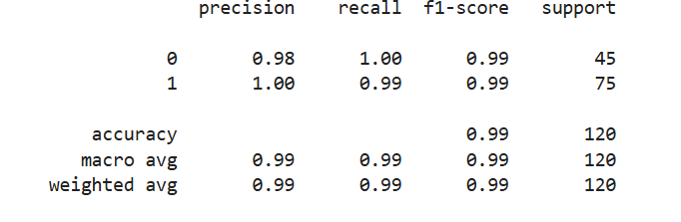
The f1_macro value for best parameter{'penalty': 'l2', 'solver': 'newton-cg'}: 0.9916844900066377
roc_auc_score=1.0

K Nearest Neighbors:
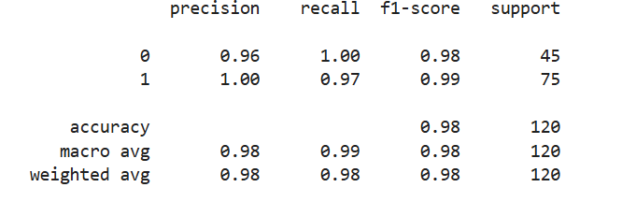
The f1_macro value for best parameter{'metric': 'euclidean', 'n_neighbors': 1, 'weights': 'uniform'}: 0.9834018801410106
roc_auc_score= 0.9866666666666667
Naive Bayes
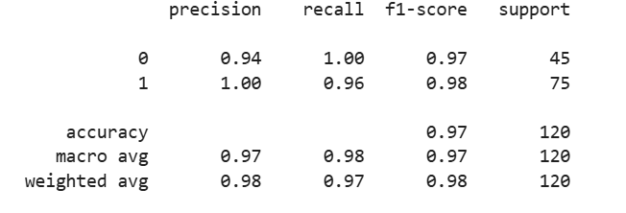
The f1_macro value for best parameter{'var_smoothing': 1e-07}: 0.9751481237656352
roc_auc_score= 1.0
Support Vector Machine Classification
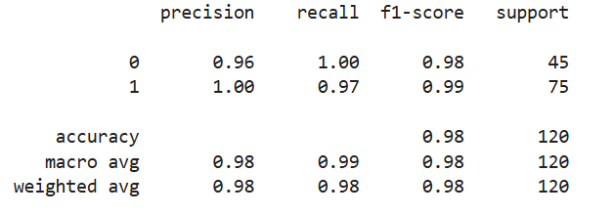
The f1_macro value for best parameter{'C': 100, 'gamma': 'auto', 'kernel': 'rbf'}: 0.9834018801410106
roc_auc_score= 0.9988148148148148

Decision Tree Classification
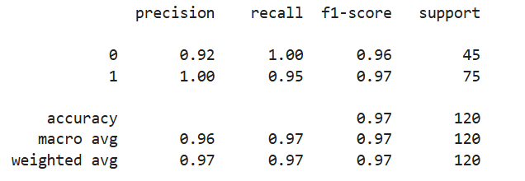
The f1_macro value for best parameter{'criterion': 'entropy', 'max_features': 'log2', 'splitter': 'random'}: 0.9669192655202565
roc_auc_score= 0.9733333333333334
Random Forest Classification
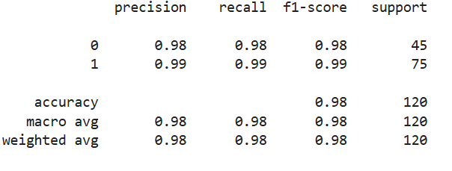
The f1_macro value for best parameter{'criterion': 'gini', 'max_features': 'log2', 'n_estimators': 100}: 0.9833333333333333
roc_auc_score= 0.9997037037037036
Step 6: Save the model
The Logistic Regression model was selected as the final model for deployment because it achieved the highest accuracy, recall, precision, f1_score, macro average, weighted average and roc_auc score compared to all other models evaluated.
The f1_macro value for best parameter{'penalty': 'l2', 'solver': 'newton-cg'}: 0.9916844900066377
roc_auc_score=1.0
Save this Logistic Regression model.
Stage 5: Deploy Phase
Step 1: Load the saved model Logistic Regression.
Step 2: Get the inputs from user such as 'age', 'bp', 'sg', 'al', 'su', 'rbc', 'pc', 'pcc', 'ba', 'bgr', 'bu','sc', 'sod', 'pot', 'hrmo', 'pcv', 'wc', 'rc', 'htn', 'dm', 'cad','appet', 'pe', 'ane'.
Step 3: Now the model predicts the whether a person has Chronic Kidney Disease or not for the given inputs.
---------------------------------------End of the Report------------------------------------------------

